Sunday 13 August 2017

Prayer before Worship:
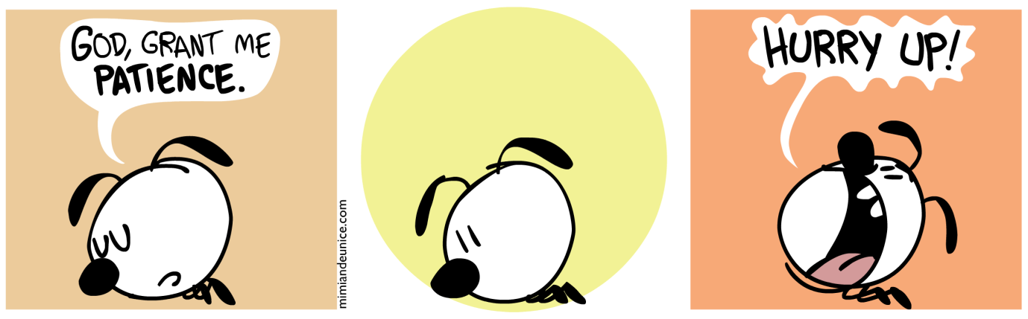

Lord, help me hit the pause button... perhaps I don’t do this enough, hitting my emotional, physical, social, or spiritual pause button. When hard things happen, I have the choice to be patient or something else –angry, sulky, distant, domineering, petty... especially with those I love the most. Grant me patience, Amen.

Welcome

Call to Worship
They that wait upon the Lord shall renew their strength
Lord we wait patiently in your presence
They that wait upon the Lord shall renew their strength
God gives power to the faint and strength to those without power
Lift us up. Lift us up!
Make us strong. Make us strong!
Help us walk. Help us run! Make us fly!
They that wait upon the Lord shall renew their strength.
Lord, we come to wait in your presence.

Songs of Praise: As we gather
Saviour, I heard
Lord I come to You

Opening Prayer Hold us close, Lord, Let Your love surround us. Bring us near, draw us to Your side. And we will wait... yes Lord, in a world of busy and action and just do it... we will wait. Because the rising, the soaring, the leading, doesn’t actually happen until we have learnt to wait. We don’t fully discover the power of your love until we have learnt the art and the discipline of waiting. So this morning we ask You to help us to wait. Take away the roadblocks that stop us from coming into your presence. Fill in the potholes that make the way bumpy. Help us to recognise you in our midst.
Help us this morning to discover more of you, and the way we can best follow you.
Almighty and loving God, You have given us eyes to see the light that fills this room,
Now give us eyes to see you in this place. You have made us so we can feel The morning wind on our faces, Now help us to sense your presence as we come and worship you. By your Holy Spirit inspire us beyond our expectations, and enlarge our faith in and beyond our understanding. Through Christ Jesus our Friend, Amen.

Birthday Basket

Offering and Dedication
O Lord, our God, your wisdom is beyond our understanding. You are the source of all goodness. Yet we chase after things of this world that do not satisfy. We spend our money foolishly and wonder why we still hunger in spirit. Thank you for patiently calling us to trust you with our whole heart. Refresh us by your Holy Spirit so that we may lead others to you. We give these offerings in the name of Jesus Christ, who calls us to lives of generosity so that everyone has enough. Amen.

God @ work Simon Tucker?

Time with the children “David’s waiting day” by Bernadette Watts

Sometimes we have to wait for a really long time –what have you had to wait for?
(your birthday to come; a visitor...)

Today we are talking about the 4th fruit of the spirit (???)
=yes, patience

And that is not just that we have to wait for some things
But that how we wait is important... sometimes what we really want to happen we have to wait a very long time for... sometimes what we ask God for we have to wait a really long time for an answer. So we get to practice good waiting.

How did David wait?
-sometimes he did well waiting –what ways?
= not moaning about the burnt toast; doing the shopping; playing while Granny made the cake; painting a picture for mummy (waiting doesn’t mean sitting doing nothing)
–other times he didn’t do so well (when Granny gave him cabbage and he got angry and had to have a rest)

How do you wait?
We can practice at being patient when we have to wait...

And we can ask the Holy Spirit to help us be patient –so we can wait well.

Lord’s Prayer

Song: I sing a song

(I sing a song of the saints of God,
patient and brave and true...) -patient!!!

Children leave for Young Church programme

Powerpoint Reflection Psalm 37:1-11, 39-40

Bible Reading: Galatians 5: 22-26

Prayer of Confession
Loving God, by desiring instant results to most things these days,
we confess that we forget what it’s like to be patient.
We find ourselves neglecting the needs of others
because we run out of time to be kind to other than ourselves.
In the stillness, we ask for your forgiveness.
When we persistently make self-centred decisions
rather than Christ-centred ones,
our understanding of your goodness and faithfulness is weakened
and our discipleship lacks credibility.
In the stillness, we ask for your forgiveness.
In this aggressive world,
it’s easy to believe one can’t get anywhere
by exercising a spirit of gentleness or even self-control.
Gracious and merciful God,
grant us your forgiveness and your love
so that we may truly care for one another.
Refresh and renew us with the Holy Spirit
so that we are fruitful and vital disciples of Jesus Christ. Amen

Assurance of Forgiveness
Those who are in Christ are a new creation:
everything old has passed away; see, everything has become new!
All this is from God with whom we have been reconciled through Christ.
(2 Cor. 5:17-18)
Thanks be to God!

Song: Be still and know

Bible Readings: Isaiah 40: 25-31
James 5:7-12

Isaiah 40: 25-31
²⁵ “To whom will you compare me? Or who is my equal?” says the Holy One.
²⁶ Lift up your eyes and look to the heavens: Who created all these?
He who brings out the starry host one by one and calls forth each of them by name.
Because of his great power and mighty strength, not one of them is missing.
²⁷ Why do you complain, Jacob? Why do you say, Israel, “My way is hidden from the Lord;
my cause is disregarded by my God”? ²⁸ Do you not know? Have you not heard?
The Lord is the everlasting God, the Creator of the ends of the earth.
He will not grow tired or weary, and his understanding no one can fathom.
²⁹ He gives strength to the weary and increases the power of the weak.
³⁰ Even youths grow tired and weary, and young men stumble and fall;
³¹ but those who hope in the Lord will renew their strength. They will soar on wings like eagles; they will run and not grow weary, they will walk and not be faint.

James 5:7-12New International Version (NIV)
⁷ Be patient, then, brothers and sisters, until the Lord’s coming. See how the farmer waits for the land to yield its valuable crop, patiently waitingfor the autumn and spring rains. ⁸ You too, be patient and stand firm, because the Lord’s coming is near. ⁹ Don’t grumble against one another, brothers and sisters, or you will be judged. The Judge is standing at the door! ¹⁰ Brothers and sisters, as an example of patience in the face of suffering, take the prophets who spoke in the name of the Lord. ¹¹ As you know, we count as blessed those who have persevered. You have heard of Job’s perseverance and have seen what the Lord finally brought about. The Lord is full of compassion and mercy. ¹² Above all, my brothers and sisters, do not swear—not by heaven or by earth or by anything else. All you need to say is a simple “Yes” or “No.” Otherwise you will be condemned.

Sermon Fruits of the Spirit: Patience

Patience is a hard discipline. It is not just waiting until something happens over which we have no control: the arrival of the bus, the end of the rain, the return of a friend, the resolution of a conflict. Patience is not waiting passively until someone else does something. Patience asks us to live the moment to the fullest, to be completely present to the moment, to taste the here and now, to be where we are. When we are impatient, we try to get away from where we are. We behave as if the real thing will happen tomorrow, later, and somewhere else. Let's be patient and trust that the treasure we look for is hidden in the ground on which we stand. –Henri Nouwen

Hymn: Speak Lord, in the stillness

Prayers of Intercession
We come to God with our prayers for other people. Let us pray.

It is not much use, Holy Friend; praying for our world-wide neighbours unless we trust you with our own lives, and what is harder, completely trust you with the lives of our loved ones. Therefore we pray that you will increase our faith and embolden us to both pray and live by it.
Loving God, teach us to trust you
Holy Friend, we pray for those far away neighbours who are in conflict: in the Middle East and Africa, South East Asia and Central America, Indonesia and the Philippines.
Loving God, teach us to trust you
Holy Friend, we pray for mistreated neighbours: suffering from extortion and injustice, political or religious oppression, cruel economic exploitation, or domestic tyranny.
Loving God, teach us to trust you
Holy Friend, we pray for neglected neighbours: homeless, misjudged, persecuted, and hungry, or consigned to unremitting poverty, hard labour, and a short life span.
Loving God, teach us to trust you
Holy Friend, we pray for near-at-hand neighbours: at work, in our street, in supermarkets, banks, schools, and hospitals; all who are in trouble and at their wits end.
Loving God, teach us to trust you
Holy Friend, we pray for our bruised and weeping neighbours: those just made redundant, pained by divorce, grieving over a delinquent child, or weeping hot tears at a grave side.
Loving God, teach us to trust you
Holy Friend we pray for the neighbours in our church: the weak and the strong, the shy and the outgoing,, the leaders and the followers, the newcomers and the familiar faces, those bearing secret burdens and those buoyant with happiness.
Loving God, teach us to trust you and to love our neighbours as we love ourselves.
Through Christ Jesus, our Saviour, Amen.

Hymn The church’s one foundation

Benediction and sung Amen
On the threshold of a new week, we go from here as the people of God,
So keep your eyes open for God, watch for His works;
be alert for signs of His presence.
Take time to pause, to wait...
Choose the way of patience
And may the peace of God that goes beyond all understanding,
keep your hearts and minds in the knowledge and love of God,
and of his Son, Jesus Christ our Lord.
And the blessing of God Almighty, the father, Son and Holy Spirit, be amongst you and remain with you always, Amen.

Sermon

You know the rhyme -Patience is a virtue possess it if you can, seldom found in women and never in a man. Well in the manse, life does not quite live that out. Richard is way more patient than me, and I seem to want everything to happen yesterday.
So –me putting together a sermon on patience... on that certain kind of waiting... on the ways we deal with the inbetween-ness of life, seemed to be something I should put off!
And as I came home from visiting yet another open home yesterday in our seemingly pointless exercise of house hunting, writing a sermon on patience was the last thing I felt inclined to do –even though I no longer had the option of putting it off.

All week I have had my eyes and ears tuned at some level to the idea of patience.
As I raced home from a meeting on the North Shore early in the week, to get home in time for the dreaded school bell... I became irritated by the slow car in front of me... and as I looked at it, I read these words... Learner driver, please be patient...

*pic*

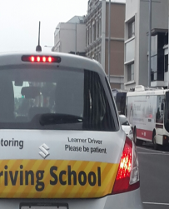
Somehow any delight that having just passed on my Ministry Work Group tasks to the new presbytery regional convenors –something I have been desperately waiting to happen for seemingly ages... was all but forgotten, as I found myself again in this moment of impatience.
And I know I do that way too often... I wait and wait for something to happen, and then when it finally does happen, I am off at once to the next thing that I am waiting for.
You may not struggle with patience as much as me, but I suspect we all have our battles with patience.
How do we remain calm when we have asked our child 5 times already to put away their school bag or to go and get changed out of their uniform.
How do we stay committed to actively loving our partner when we are tired and they are not behaving the way we had hoped.
How do we listen to the same story being told yet again and we know the time is ticking.
How do we keep remaining open to the possibility of a friendship or relationship that we so would love to enjoy.
How do we keep on at the job we struggle with when we long for something more or something different.
How do we look at our physical body that has started to fail us and remain content.

There are so many aspects in our lives that seem to require –even demand patience of us. And our response to the waiting –the how of our response –has this huge impact on our overall well being.
And the reality is that I could come home from the open homes to write my sermon because in between those two things I was blessed by a phone call –I could talk to my sister who –in her amazing way – could draw me back to the hard task of waiting, whilst being able to remind me to be thankful for the rest.

I pondered what the opposite of patience is...and - obviously, you respond, it is impatience. But what does impatience actually look like in your life?
Does it look like anger? anxiety? pushiness? Turning inward? Grumpiness?
I suspect our initial response is probably personality driven –the extroverts might lash out while the introverts might turn in on themselves.
But as we go a bit deeper, I think our answer to how we understand impatience will also give us a glimpse of how we see patience.

And I turned to the Bible. Our reading from Isaiah reminds us that our patience is based in our trust that God is so much bigger than us –we can be patient because we can trust God.
God asks Isaiah –why do you people complain? Don’t you know that God is the Creator? –God doesn’t get tired or weary –and God will give you the strength you need. Your job is to wait on God, and God will renew your strength.

And then in James we see patience as lived out by the farmer who waits for the spring rains and the crops to grow –and who, while he waits, does not grumble.
*pic*

So, as I turned to Scripture I was reminded that there is a lot of waiting expected of God’s people. All though the Bible we see people having to wait. -God generally only moves after there has been significant waiting. So the question is not if we will have to wait, but how we will wait. What will our waiting look like? Will we wait passively or expectantly? –With a wishbone or a backbone?
How are we to understand such patience?

Henri Nouwen talks of patience as a hard discipline. He says –
It is not just waiting until something happens over which we have no control: the arrival of the bus, the end of the rain, the return of a friend, the resolution of a conflict. Patience is not waiting passively until someone else does something. Patience asks us to live the moment to the fullest, to be completely present to the moment, to taste the here and now, to be where we are. When we are impatient, we try to get away from where we are. We behave as if the real thing will happen tomorrow, later, and somewhere else. Let's be patient and trust that the treasure we look for is hidden in the ground on which we stand.

So the first thing we need to understand about patience is that it is not passive. Patience opens us to active waiting. A common piece of advice given to those starting to serve a prison sentence, is –You do the time; don’t let the time do you. How we wait becomes extraordinarily important.
To wait means to expect or to look for, but it also means to serve –the waiter waits on your table at a restaurant. Waiting isn’t just active, it involves service.
Patience often gets connected in our heads with powerlessness... because people in authority are often the ones who tell us we have to wait and we are not fully informed or we are told to wait as a way of avoiding action. Waiting becomes passive. But the word patience actually involves the opposite of passive waiting in which we let things happen and allow others to make decisions.
Patience means to enter the thick of things –seeing, hearing, touching, tasting, smelling as fully as possible. It is to neither flee or fight –whether in our heads or physically. Impatience flees or fights. Impatience experiences uncomfortable moments as empty or meaningless. So we tend to wither fight those who disagree or challenge or we flee the situation. But beyond the choice of flee or fight is actually a third option –to stay patiently. Living it through, listening to what is happening, remaining present.

The word Patience in the Greek is hypomone –and it is a compound word made up of two other words: hypo (a preposition meaning 'under') and moneo (a verb meaning to 'remain' or 'abide'). So when the two come together you get the idea of remaining or abiding under difficult circumstances. It is remaining fully in the situation.
Secondly, patience knows that there is no quick fix. Patience never knows how long it must wait. Many chapters of our lives require long commitments. Our society tells us there is a quick fix for everything, but that is not true. Patience invites us to trust the fullness of God’s time.
In Christ we not only called to live with a new mind, but also within a new concept of time. Patience involves understanding the fullness of time. When we are slaves to the clock, our time remains empty and we can miss the moments of grace and salvation. Impatience tempts us to run from a painful moment in the false hope of finding our treasure elsewhere. Patience is willing to wait until we discover the treasure under our feet.
And thirdly -an aspect of patience I hadn’t really considered is Henri Nouwen’s assertion that patience gives us time to be available to others. Waiting gives us a choice between fretting in isolation and including those around us. Often when we are waiting, if we actually look around us we will find that there are others waiting alongside us, others who we can share our waiting with.

We are called to be patient in our relationship with God, patient in our relationships with others and patient with ourselves. It is no easy task. When things are easy and good, we don’t really need patience... but when life is difficult, that is when patience come into its own. And so we are wise to practice patience in the small moments, so we have some experience for when we need it in the big moments.

You may have some big things you are needing patience for at the moment, but even if you don’t, it is worth working on patience in the small things –the traffic jams, the boring conversations, the niggles in relationships...
Make the decision this week to wait well. So yes, here it comes, -this week’s challenge

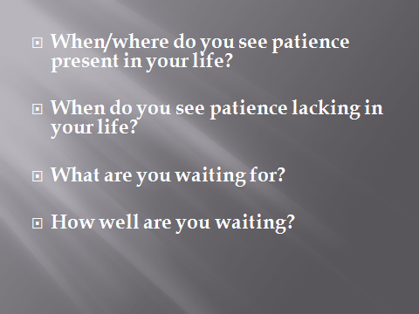
*pic*

Take a few minutes to reflect how patience features in your life...

This week, allow yourself to pause, to wait, to be actively patient...

And let me finish with the prayer from the order of service -
Lord, help me hit the pause button... perhaps I don’t do this enough, hitting my emotional, physical, social, or spiritual pause button. When hard things happen, I have the choice to be patient or something else –angry, sulky, distant, domineering, petty... especially with those I love the most. Grant me patience, Amen.

